 ContactManager

Investigation Exercise

1. If you have not done so yet, configure ClaimCenter and ContactManager to be integrated. Test your integration by executing a search on ClaimCenter's AddressBook tab for "Health South".

Note: Do not modify the plug-in if your installations were done in advance.

Follow the instructions below to observe the behavior of exact and potential matching.

2. In ClaimCenter, log on as Andy Applegate and search for all contacts of type Person whose last name starts with "Hind". How many records were returned?

3. Navigate to claim 235-53-365870. Create a new single-use contact (using the "New Contact" button) of type person with a first name "E" and a last name "Hind" who has a role of witness. Do not provide any further information about the contact. The new contact should be unlinked. How can you tell?
4. Attempt to link the contact by clicking the Link button. The link will fail. Answer each of the questions below.

4a) Did ContactManager attempt to find an exact match? If so, was one found?
4b) Did ContactManager attempt to find a potential match? If so, was one found?
4c) Did ContactManager create a copy of the CC contact? If not, why not?
5. Open the resource in ContactManager that specifies the logic for exact matching for person contacts. Which field or fields would the "E Hind" record need to match in order for ClaimCenter to find an exact match?
Configuration Exercise

Configure ClaimCenter to meet the following customer requirement from Acme Insurance.

Requirement 1: Add a Preferred Field to Person

Acme Insurance wants to be able to mark contacts who are acting on the claim in the capacity of an official. This information is relevant to claims processing, but it should not be captured in the address book.

6. Configure ClaimCenter such that it meets the following criteria:
- The Person entity has a Boolean (bit) field named "IsOfficial".
- The field does not exist in ContactManager's ABPerson entity.
- The field does not interfere with the syncing of a Person to an ABPerson.
- There are appropriate display keys and modifications to the appropriate PCFs to display the new property.

Test Case 1

When you have completed your configuration, deploy your changes and run the following test cases:

7. Regenerate the data dictionaries for both applications. Confirm that ClaimCenter's Person entity has the new field and ContactManager's ABPerson entity does not.

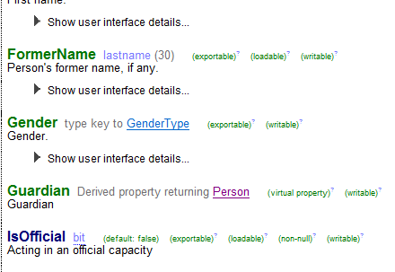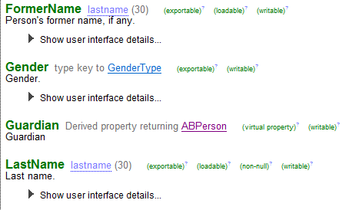

8. Login as Sue Smith (ssmith) to verify that you can create a new contact on a claim of type Person that is linked to an ABPerson. (In other words, verify that the new field does not interfere with the syncing of Person and ABPerson objects.)
Requirement 2: Modify Matching Behavior

Complete this requirement only if your instructor tells you to do so.

When attempting to link a record, Acme Insurance wants to return an ABPerson as a potential match if the LastName field starts with the same string as the ClaimCenter Person's last name.

9. Configure ContactManager such that an ABPerson is a potential match if the LastName is simply the same as the ClaimCenter Person's last name (regardless of the Tax ID value or any others). In other words, a last name of "Gilmour" is a potential match to any record whose last name is "Gilmour" regardless of other criteria. In order to make your changes take effect, you must stop and restart ContactManager.

Test Case 2

When you have completed your configuration, run the following test cases:

10. Navigate to the address book in ClaimCenter and create a new Person contact named Dennis Hinds with a Tax ID you know will be unique.Verify that Adam and Erica Hinds are returned as potential matches.
